**DA ASSIGNMENT – 4**

**NAME : B.JAYAMALA**

**REGISTER NO : 723920243016**

Create two list and join those two list :

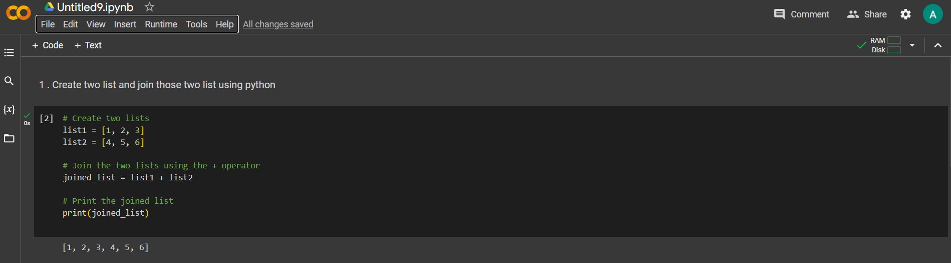

With If statement find the even numbers :

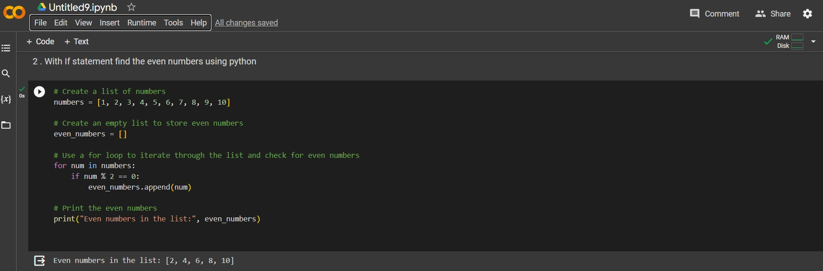

Create a dictionary with 3 keys and 2 values for each key :

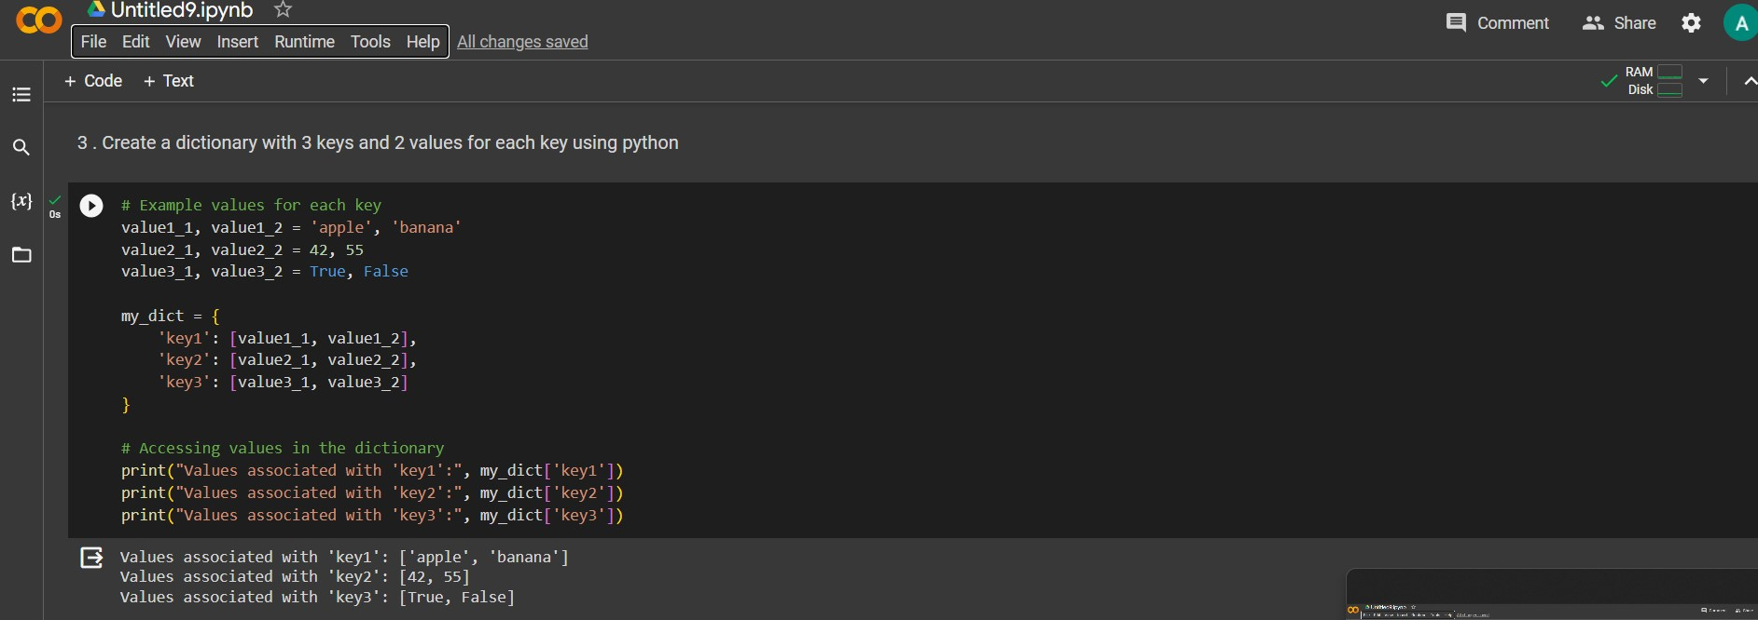

Create a function with If statement which is used to find the odd numbers :

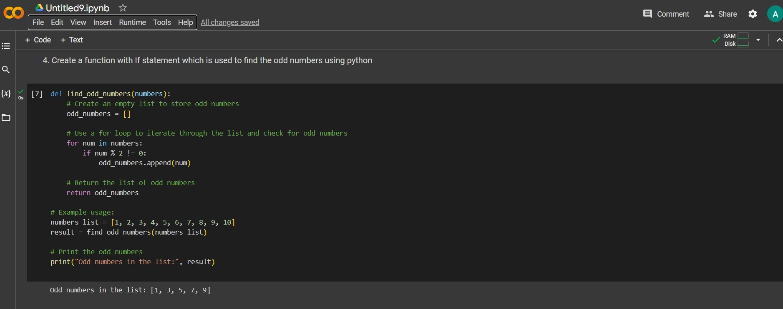

Write a Python function to sum all the numbers in a list :

